**ASWIN K**

**231501027**

**EXPERIMENT 4**

# AIM:

To create a web-based Java Servlet application that accepts a user's name and age through an HTML form and displays the submitted data back on the browser using Java Servlet technology.

# CODE:

<!DOCTYPE html>

<html>

<head>

<title>User Form</title>

<style>

body {

font-family: Arial, sans-serif; background-color: #f4f4f4; display: flex;

justify-content: center;

align-items: center; height: 100vh; margin: 0;

}

.container { background: #fff; padding: 20px; border-radius: 10px;

box-shadow: 0px 0px 10px rgba(0, 0, 0, 0.1); text-align: center;

width: 300px;

}

h2 {

color: #333;

}

input[type="text"], input[type="number"] { width: 90%;

padding: 10px; margin: 10px 0; border: 1px solid #ccc; border-radius: 5px;

}

input[type="submit"] { background: #007BFF; color: white;

padding: 10px 15px; border: none;

border-radius: 5px; cursor: pointer; font-size: 16px; width: 100%;

}

input[type="submit"]:hover { background: #0056b3;

}

</style>

</head>

<body>

<div class="container">

<h2>Enter Your Details</h2>

<form action="UserServlet" method="post">

<input type="text" name="username" placeholder="Enter your name" required><br>

<input type="number" name="age" placeholder="Enter your age" required><br>

<input type="submit" value="Submit">

</form>

</div>

</body>

</html>

## Java Servlet :

import java.io.IOException; import java.io.PrintWriter;

import javax.servlet.ServletException; import javax.servlet.annotation.WebServlet; import javax.servlet.http.HttpServlet;

import javax.servlet.http.HttpServletRequest; import javax.servlet.http.HttpServletResponse;

@WebServlet("/Exp4") // Make sure your form action matches this URL public class Exp4 extends HttpServlet {

protected void doPost(HttpServletRequest request, HttpServletResponse response) throws ServletException, IOException {

response.setContentType("text/html"); PrintWriter out = response.getWriter();

// Retrieving form data

String name = request.getParameter("username"); String age = request.getParameter("age");

// Output HTML response out.println("<html><body>");

out.println("<h2>Welcome, " + name + "!</h2>"); out.println("<p>Your age is: " + age + "</p>"); out.println("</body></html>");

}

}

## Configure web.xml:

<web-app xmlns="<http://java.sun.com/xml/ns/javaee>" version="3.0">

<servlet>

<servlet-name>UserServlet</servlet-name>

<servlet-class>UserServlet</servlet-class>

</servlet>

<servlet-mapping>

<servlet-name>UserServlet</servlet-name>

<url-pattern>/UserServlet</url-pattern>

</servlet-mapping>

</web-app>

# OUTPUT:

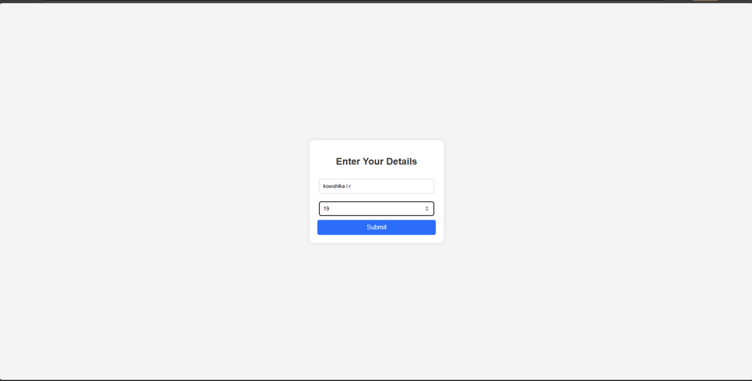

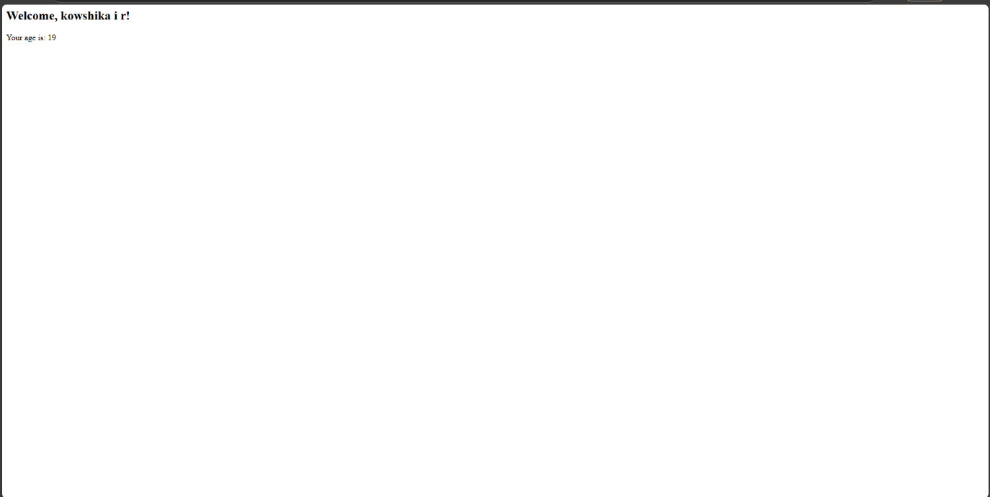

**RESULT :**

Thus the give program is executed successfully.